Developing in a DevOps Environment
Module 6 Assignment Part Three
Nick Martens

Screenshot 011:
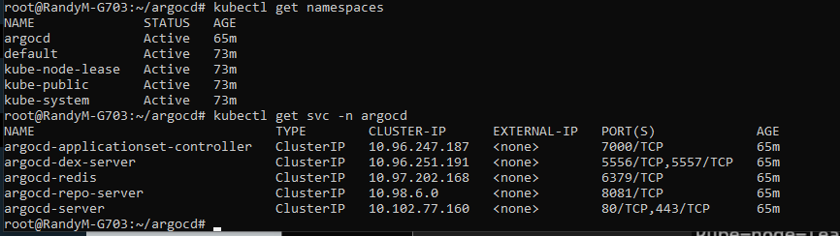
Namespaces and Argo cluster
Screenshot 012:
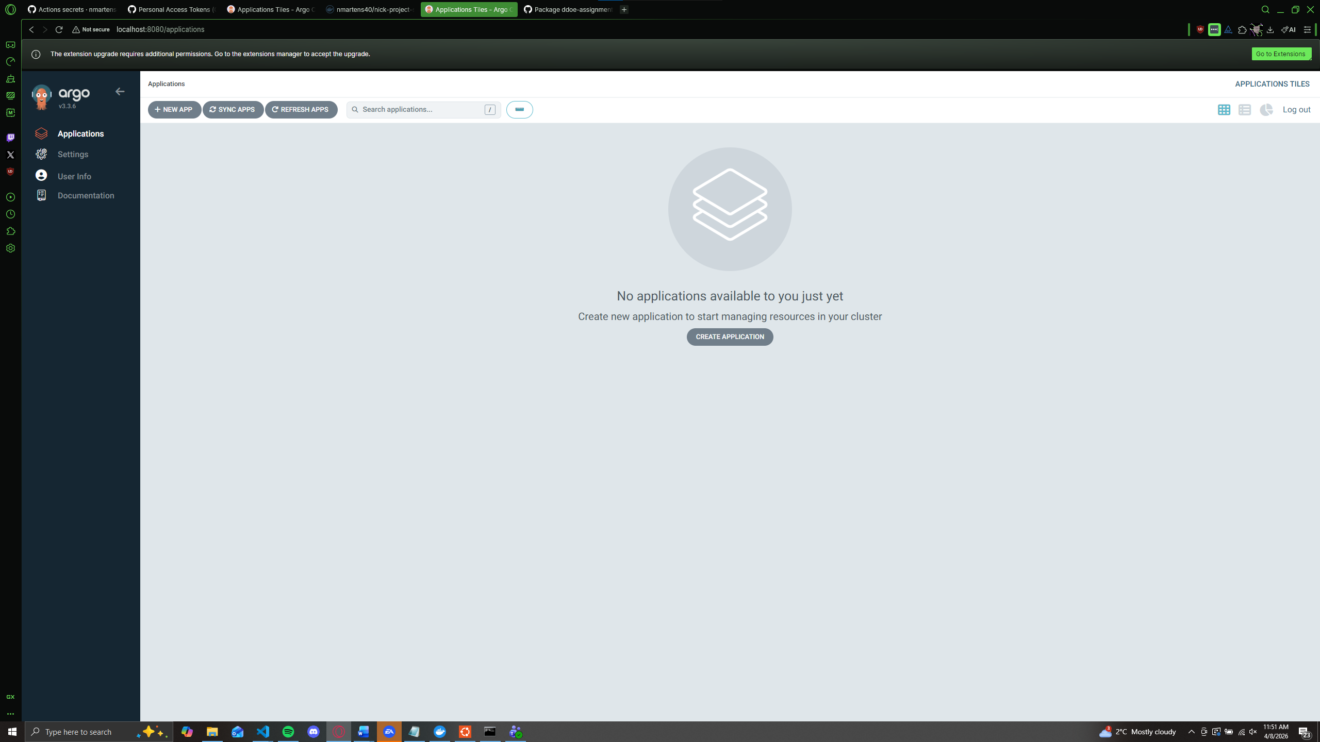
Empty Applications screen
Screenshot 013:
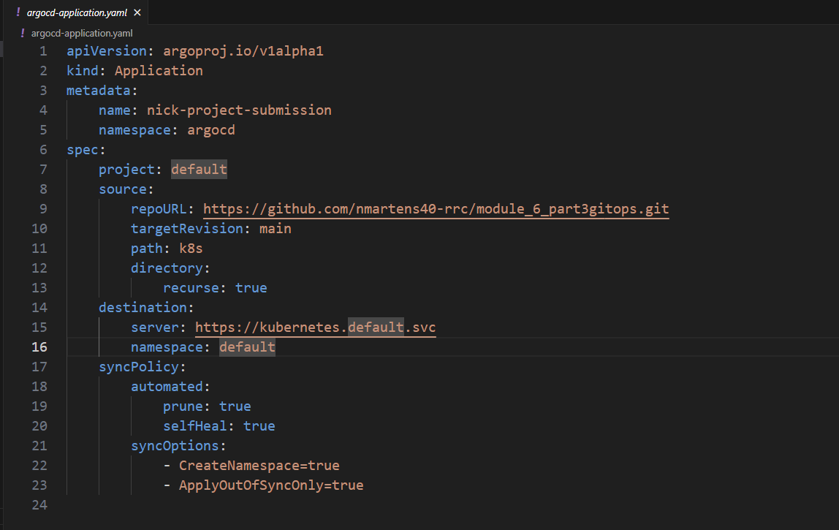
ArgoCD yaml
Screenshot 014:
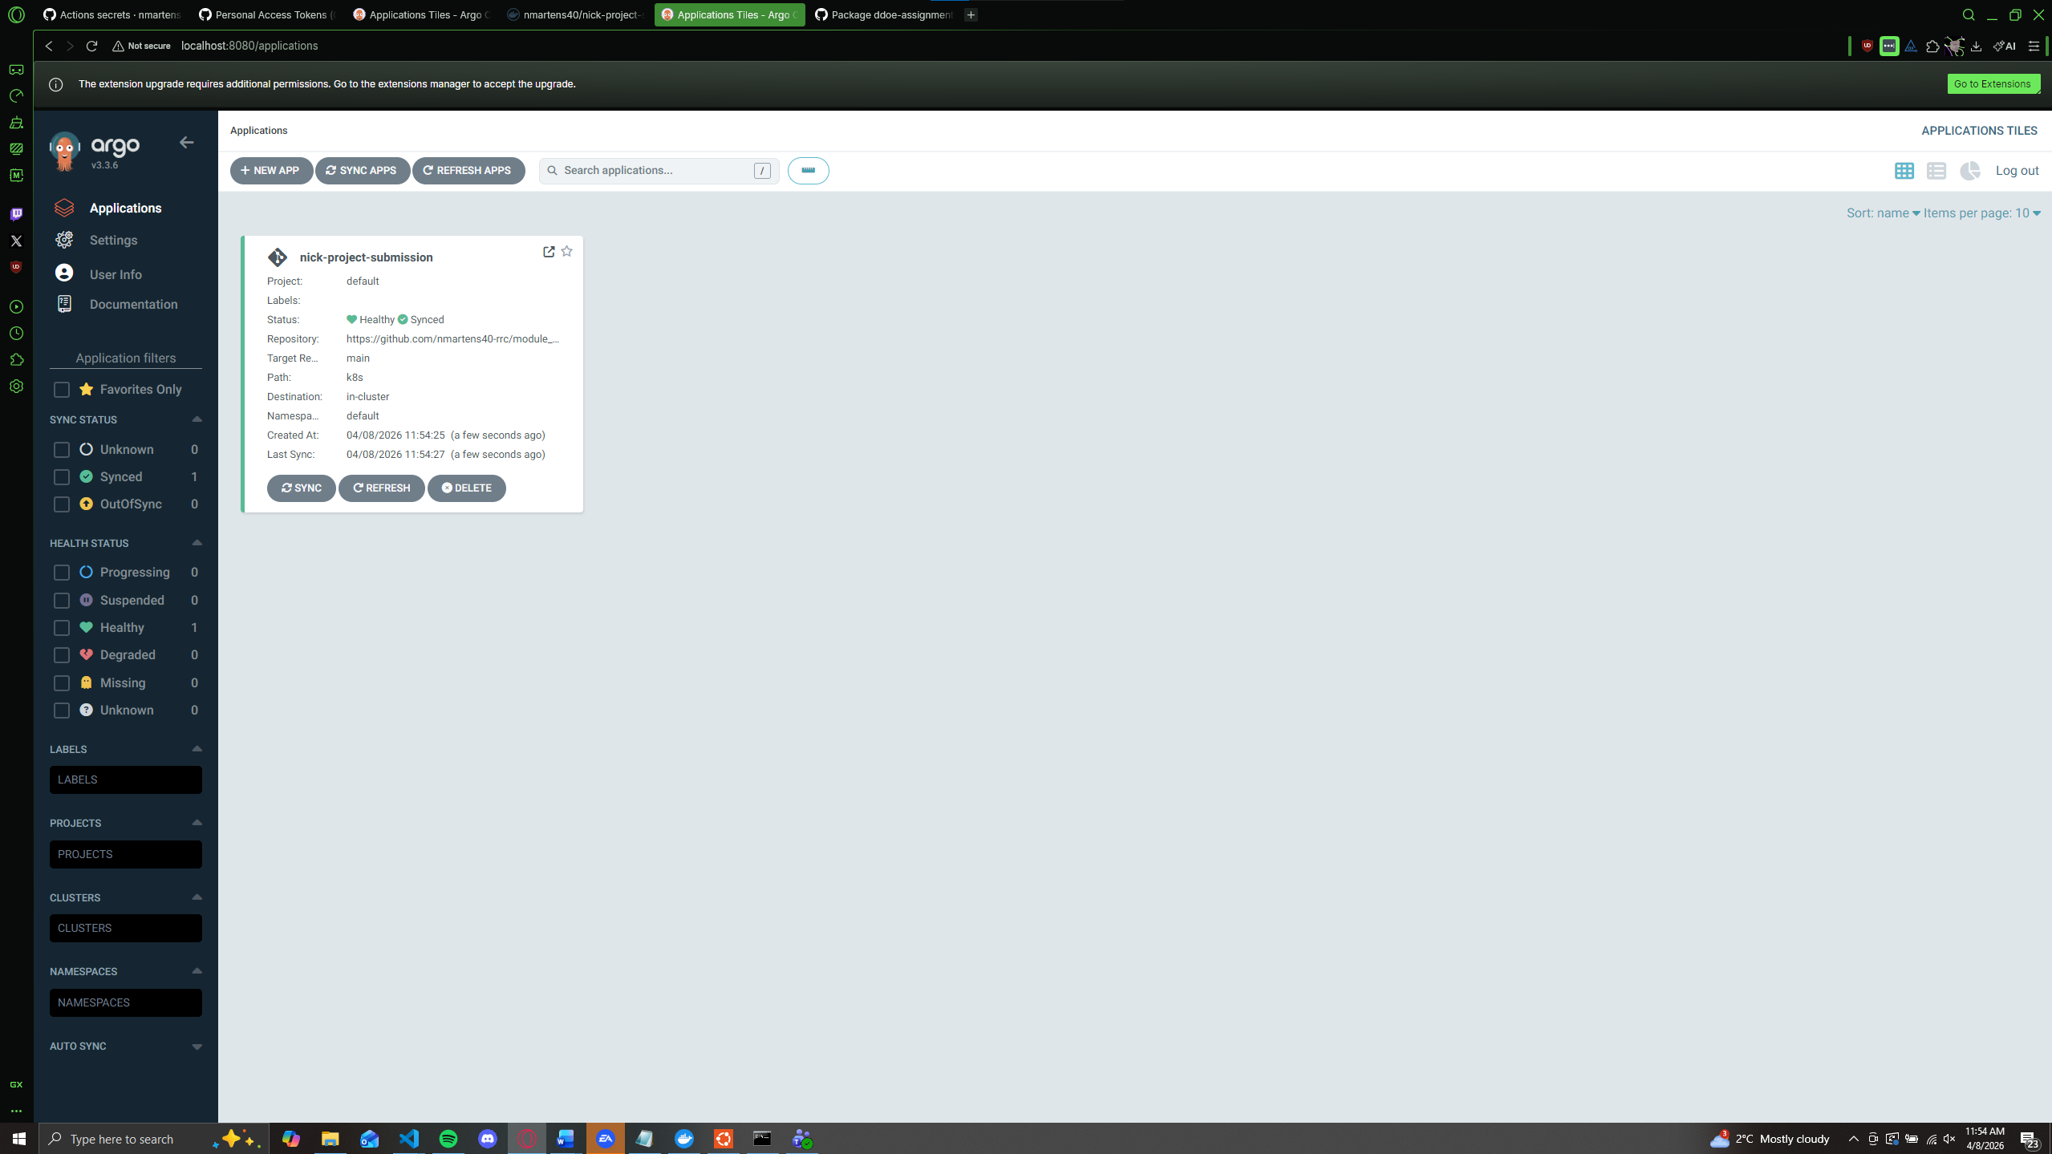
Application created and shows up in ArgoCD
Screenshot 015:
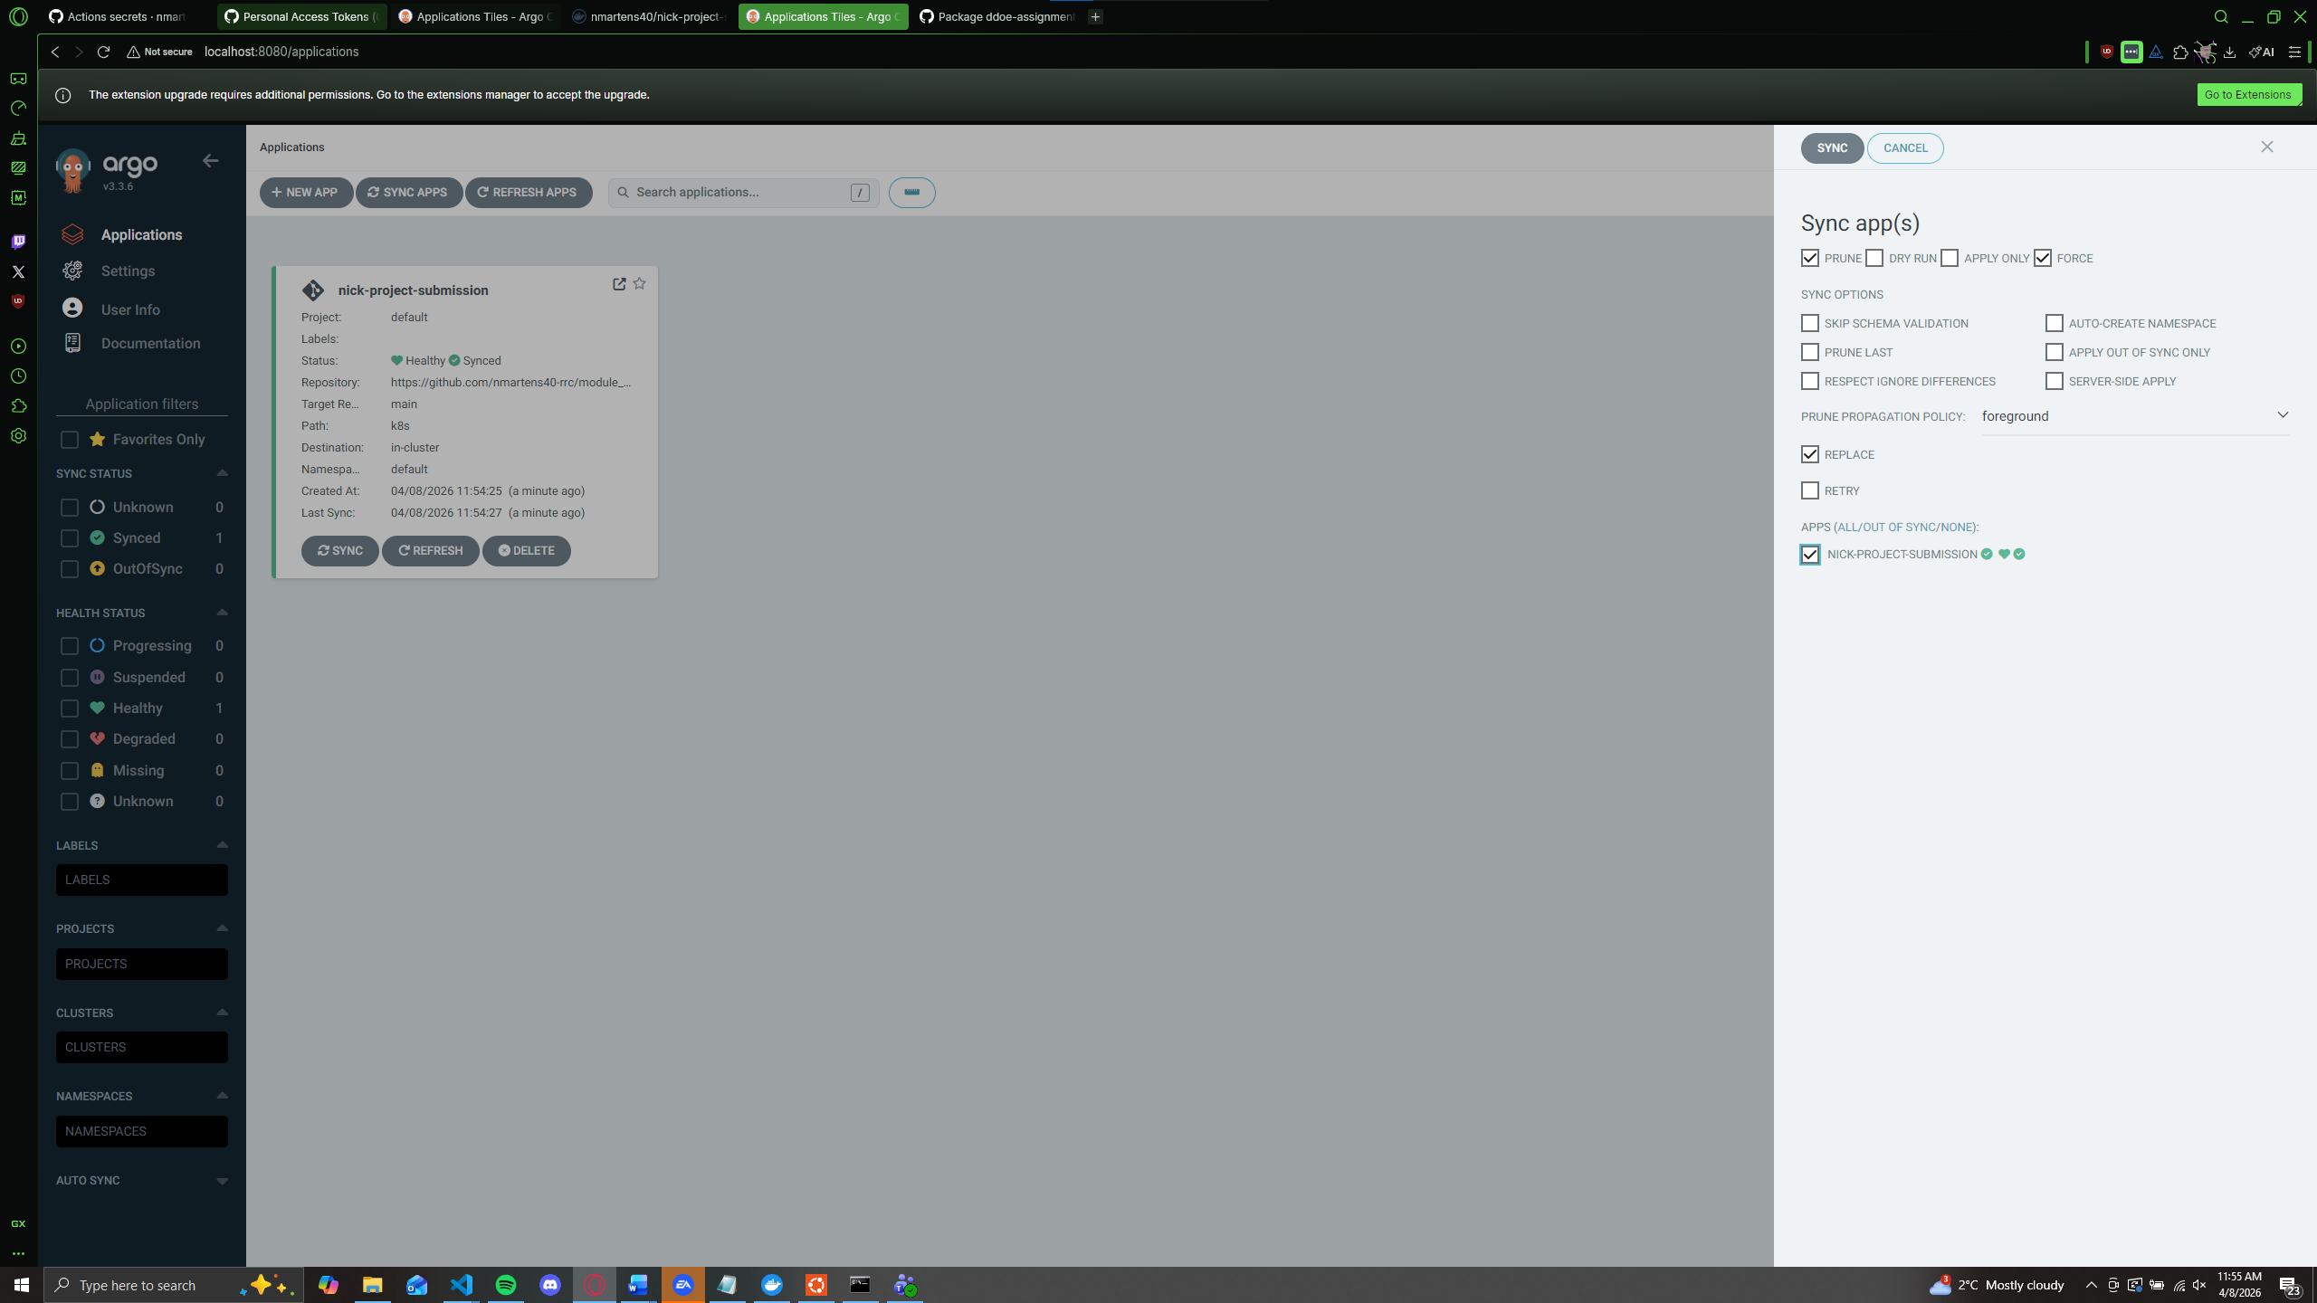
Resyncing application
Screenshot 016:
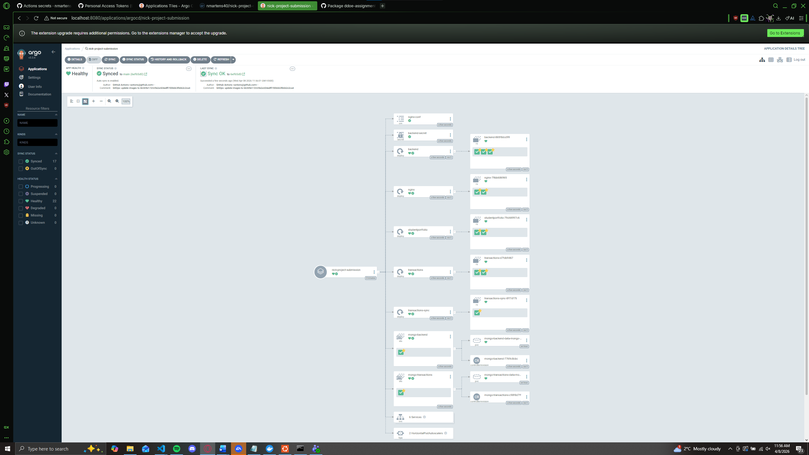Node tree showing application pods and health status

Questions:
Drift Detection
- When I change the replica amount manually, Argo shows another pod deploying and shows the current and desired state.
- If you change any parameters manually, using the yamls for the deployment as a source of truth doesn’t work as the manual changes only affect the current deployment. This means that Argo is the only single source of truth as it updates dynamically and displays even manual changes.

Rollbacks
- After rolling back to a previous commit, Argo redeploys the application using the previous version. Automatic rollbacks make rolling back much faster than doing it manually. This is extremely helpful if you release a broken version of the application and you need to keep it functional for users. Its also safer due to the user not having to change files back to their previous state which could result in different issues due to user error. Instead, Argo’s automatic rollbacks grab the previous files and re-deploy making it work every time.

Syncer Purpose
- The purpose of the syncer is to sync the transactions and banking app databases every 300 seconds (5 minutes). This keeps data consistent across multiple databases.

